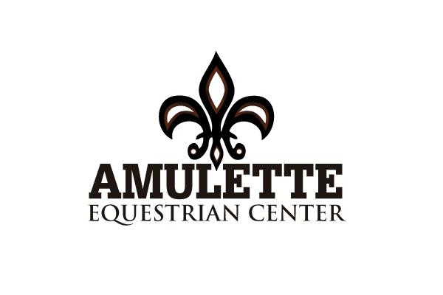

RELEASE AND HOLD HARMLESS AGREEMENT

The participant acknowledges the inherent risks which are involved in riding and working around horses. These risks may include, but are not limited to, damage to personal property, illness, bodily injury, trauma, or death resulting from a fall or while riding or being in close proximity to horses.
The Participant further understands that both horse and rider can be injured in the normal course of events while hacking, schooling, or competing, and therefore agrees to indemnify and hold harmless Amulette Equestrian Center and its employees, and further release them from any liability or responsibility for any accident, injury, damage, or death to the Participant or any property or horse the Participant owns, or to any family member or spectator accompanying the Participant owns, or to any family member or spectator accompanying the Participant while on the premises of Amulette Equestrian Center.
WARNING
Under Missouri law, an equine professional is not liable for an injury to or the death of a participant in equine activities resulting from the inherent risks of equine activities pursuant to the Revised Statutes of Missouri.

_________________________________________________ ________________
Signature of Participant (or Parent or Guardian is under 18 years of age) Date

______________________________________________________________________
Name (Printed)

______________________________________________________________________
Address

______________________________________________________________________
City State Zip Code

